09.02
Supplier Management
Process Design & AMOS Configuration Document
Purpose
This Process Design document is provided to Key-Users to record their key decisions regarding the AMOS Process design and the required AMOS configuration.
It is updated throughout the Project Definition Phase and used as the baseline for the Final Acceptance prior to Go-Live
Revision
Author, Name | Date | Notes
Daniele Musella | 01.06.2024 | First version

Table of Contents

1. Process Overview & Objectives 3
2. Regulatory References 3
3. Definitions & Glossary 3
4. Process Tasks 3
5. Process Dependencies 5
6. Process Flow 6
7. Process Design Questions 7
8. Data Source Mapping 9
9. Other Software Used 9
10. AMOS Configuration 10
a. Process specific configuration programmes 10
b. Basic Data 10
c. Parameters 10
d. Workflows 10
e. Scheduled Tasks 11
f. API’s & Interfaces 11
11. UAT Guidance 11
12. Annex – Additional Info 12

Process Overview & Objectives
Process General Description
This Business Process explains how to create and manage external addresses used in AMOS for Suppliers of material and services. It also shows how to setup the different contract types and how to create a Price Book.

Main Process Objective (Outputs & Outcomes)
The main objective of Supplier Management is:
- To create and handle the master data of all your suppliers of material and services in AMOS, so as they can be used later in all processes of Procuring and finance.
- To create and handle Contracts with your suppliers of material and services, according to the different contract types available.
- To create and handle Price Books, both in relation to Contracts and as “stand alone” Price Books.

Regulatory References
There is no worldwide authority regulation applicable to this process.

Definitions & Glossary
Key-Words | Explanation
Pool Contract | To manage your contracts with your pool providers, as a pool participant (you are requesting parts from a pool provider) you need to define one or several pool contracts in the Contract Management (APN 780) prior being able to issue pool requests. Usually, the material included in a Pool Contracts are Rotables
Partner Company | In a Pool Contract (you are the pool customer) with this term the pool provider is named in AMOS. Its address code needs the property "Pool Participant" in Address Administration.
Consignment Contract | To manage your contracts with your vendor, as a pool “Consignee” (you are requesting parts from a “Consignor”) you need to define one or several Consignment contracts in the Contract Management (APN 780) prior being able to Consignment Orders. Usually, the material included in a Pool Contracts are Consumables, but AMOS can also accommodate creation of Consignment contracts for CR and Rotables.
Project Contract | This type of Contract is usually used for third party maintenance to your customers, but it can also be used as reference for your supplier with the main purpose to create a Price Book for Material and/or Services covered by the Contract

Process Tasks
The main business processes and related AMOS APNs are the following:
Creation and handling master data of your vendors
In APN 53 (Address Administration) you can manually create master data of your vendors in terms of: address code, physical address, communication channel, type of address (Property; Supplier, Repair Station, Pool Participant, and so on), currencies, order conditions (incoterms, payment terms, method of transportation), order surcharges, creditor account and applicable taxation.
From here it is also possible to put/remove a supplier from the blacklist.
AMOS can be:
- either the “master” system for master data of vendors, namely the main system where master data of vendors are created and then exported via interface to an external ERP system (via Export Supplier Interface)
- or the “slave” system for master data of vendors. In this case the master data of vendor are created in an external ERP system and then imported in AMOS via interface (via Import Supplier Interface)

Creation and management of certification for your Suppliers
Best practices require that your supplier should be certified by Quality department prior to issue an order towards them. In order to achieve this, you need to create a certificate of type “IA” (Internal Approval) in APN 53 and then to check, in APN 1014>Orders>Extra, the parameter [UIA] (Only internally approved vendors are useable) for all order types you require that vendors should be internally approved. For non-approved vendors it is possible to define, however, if some material type can still be ordered (for example: from non-approved vendors, only non-aeronautical material can be ordered). This behavior can be set via parameter 1728 (Internal Approved Vendors Exclude Material Type).

In APN 53, however, it is only set the outcome of certification process performed by Quality department, that is described in the AMOS process 04.05 Quality Audit.

Creation and management of Contracts with your supplier
The main Contract types available in AMOS are:
- Pool Contract as Customer (contract type= POOL_PAR). To manage your contracts with your pool providers, as a pool participant (you are requesting parts from a pool provider) you need to define one or several pool contracts in the Contract Management (APN 780) prior being able to issue pool requests. Usually, the material included in a Pool Contracts are Rotables.
Preconditions to create a contract is that your pool provider has the property PO (Pool Participant) in APN 53.
In a Pool Contract you must define the “effectivity” of the contracts in terms of Aircraft covered and Part Numbers covered.
In addition, it is possible to define the contractual Base Kit level (either at global level or per station) so as, during the operation of the contract, it is possible to compare the current stock level with Contractual level (APN 2028, Pool Base Kit Report).
- Consignment Contract (contract type=CONS). To manage your contracts with your vendor, as a pool “Consignee” (you are requesting parts from a “Consignor”) you need to define one or several Consignment contracts in the Contract Management (APN 780) prior being able to Consignment Orders. Usually, the material included in a Pool Contracts are Consumables, but AMOS can also accommodate creation of Consignment contracts for CR and Rotables.
In a Consignment Contract you must define
  - the “Supply Scope” of the contracts in terms of material covered (at material class and/or material type and/or part special, or even at part number level). This scope can be defined at global level or even broken down at station level.
  - The “Price Book” of the single parts covered by the Consignment Contract that will be used during the SI-order process and that will be used as a reference also for in the automatically created SP-order (default behavior that can e changed via parameter)
  - The “aggregation strategy” of the SP-order for the material consumed from the Consignment Stock (all parts consumed within the defined period will be aggregated in a single SP-order)
- Pool Contract as Provider (contract type= POOL_PRO). To manage your contracts with your pool customers, as a pool participant (you are sending parts to pool customers) you need to define one or several pool contracts in the Contract Management (APN 780) prior being able to issue pool requests. Usually, the material included in a Pool Contracts are Rotables.
Preconditions to create a contract is that your pool provider has the property PO (Pool Participant) in APN 53.
In a Pool Contract you must define the “effectivity” of the contracts in terms of Aircraft covered and Part Numbers covered.
In addition, it is possible to define the contractual Base Kit level (either at global level or per station) so as, during the operation of the contract, it is possible to compare the current stock level with Contractual level (APN 2028, Pool Base Kit Report).
- Project Contract (contract type= PROJECT). This type of Contract is usually used for third party maintenance to your customers, but it can also be used as reference for your supplier with the main purpose to create a Price Book for Material and/or Services covered by the Contract.
- PBH (Power by the Hour) Contract (contract type= PBH). Usually, PBH is the type of commercial agreement for Pool Contracts. This type of contract allows setup a counter for cycles or flight hours of aircrafts or components. Then is defined a rate to calculate the costs per FH or Cycles and a report is produced (see APN 1333).
  - If it’s a PBH contract with a customer: It’s possible to issue a bill from PBH Contract Reporting (APN: 1333). A project can be created (but it’s not mandatory) just to aggregate the Orders and other activities related with the PBH contract.
  - If it’s a PBH contract with a supplier: to be able to do the Invoice Checking in AMOS, we recommend to use the PBH Contract Reporting (APN: 1333) to take the amounts and create a Service Order with a Service Part Number (for example: PBH_LHT_Montly_fee) with those amounts and ‘book’ the order to be able to close the Invoice.
A Financial Project can be created just to aggregate the Orders and other activities related with the PBH contract.

Process Dependencies
INPUT | CONCURRENT | OUTPUT
- Vendor Data manually entered in AMOS  - Vendor Data automatically imported from external ERP system  - 04.05 Quality auditing (to create certificates)  - Catalog List Price of OEM manually entered or automatically imported in AMOS (Price Book) | - 04.04 Approval Control – to monitor the approval of the orders issued (especially for SI-Orders and S-orders linked to Pool Contracts) | - 09.03 Ordering  - 09.04 Repair & Exchange  - 09.06 Pooling & Consignment  - 12.01 Financial Accounting  - 12.02 Invoice Checking

Process Flow
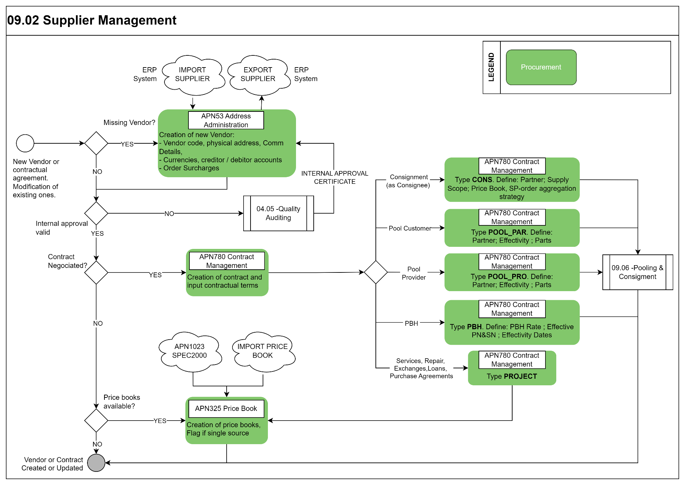

Process Design Questions
# | Question | Answer
1 | Will you import suppliers from ERP via interface? Which will be the leading system for the master data of vendors: ERP or AMOS?
2 | What AMOS Address-Code will be used for Suppliers/Vendors (e.g. CAGE code)?
3 | Will Spec-2000 e-commerce interfaces be used? If so for which Suppliers/Vendors?
4 | What is the company-wide process for the creation of new Vendor/Addresses?
5 | Which department(s) enters and controls new Addresses in AMOS? Updates? Vendors/Suppliers
6 | Are you currently using a supplier evaluation system? Who performs the supplier evaluation and how (methods, tools)?
7 | Do you internally approve your vendors? If so, what vendors for what type of material/service (e.g: all vendors where I purchase aeronautical material must be certified)?
8 | Who performs internal approval? Quality department?
9 | Should the system stop you if you try to issue orders against non- internal certified vendors?
10 | Do you have Pool Contracts? If so, are you the pool customer or the pool provider? How do you currently handle them?
11 | Do you have Consignment Contracts? If so, as customer (you are the consignee) or as a provider (you are the consignor)? How do you currently handle them?
12 | Do you have Contract for purchasing of material? If so, what kind of contract for what type of material? How do you currently handle them?
13 | Do you have Contract for purchasing of services? If so, what kind of services? How do you currently handle them?
14 | Is there a separation between the “Commercial Definition” & “Contract Management”?
15 | Do you currently import CLP (Catalog List Price) in electronic form in your system? If so, through SPEC 2000 protocol or other?

Data Source Mapping
Data Sources | Description | Volume / Manual / Automatic / Static / Dynamic
-/- | -/- | -/-

Other Software Used
Other Software | Used by: | Description
-/- | -/- | -/-

AMOS Configuration

Process specific configuration programmes
AMOS APN | Notes
APN:53 Address Administration | Define the supplier data, as required.

Basic Data
Basic Data Table | Notes
Address Certificate Type | This table contains the Address Certificate Types to be used in program Address Administration, tab sheet Certificates.
Address Communication Type | Communication types can be defined here. They are used in Address Administration for a certain address like the phone number of the main contact persons or special information needed by an interface.
Address Property Type | This table contains the Address Property Types to be used in program Address Administration, tab sheet Properties.
Address Type | Address type definition which is used in Address Administration for a certain address. So an address can be of a type main address which has several departments under it.

Parameters
Parameter Code | Parameter Name | Notes
1273 | UPPER CASE IN ORDER TEXT
1318 | USE SUPPLIER RATING
1417 | USE NEW STOCK ACCESS LOGIC
1438 | ENABLE CREDIT LIMIT CHECK

Workflows
Workflow Number | Workflow Name | Workflow Setup Notes
34 | Request Cert. Approval | This workflow is triggered when an internal approval for an address certificate is requested.
35 | Deny Cert. Approval | This workflow is triggered when an internal approval request for an address certificate is denied.
36 | Confirm Cert. Approval | This workflow is triggered when an internal approval request for an address certificate is confirmed.
161 | New Address Stored | This workflow is triggered when a new address will be stored.
162 | Address Property Stored | This workflow is triggered when an address property will be stored.
229 | Address saved (pre-save) | This workflow is triggered before an address is saved.
453 | Address saved (post-save) | This workflow is triggered after an address is saved.
77 | Notification date due | This workflow is triggered when a contract is found that has a due notification date. You need to setup the ContractNotificationTask in AMOS Scheduler Task Editor for this workflow.
308 | Contract Saved | This workflow is triggered when a contract is saved.

Scheduled Tasks
Scheduled Task Reference | Frequency | Notes
InitializeAddressEntityAccounting | Daily or on demand
ContractNotificationTask | Daily

API’s & Interfaces
Reference | Direction | Trigger | Frequency
EXPORT SUPPLIER | Export | Export supplier/address information to an external ERP system | Daily or on demand (e.g. when a new address is created/saved)
IMPORT SUPPLIER | Import | Import supplier/address information from an external ERP system | Daily or on demand

UAT Guidance
1 | To create a Supplier in AMOS (APN 53) entering all required data, including communication data, property (e.g SU), Order conditions and so on,
2 | To create an Internal Approval certificate (APN 53) and see the AMOS behaviour in APN 2015 for approve/not approve vendors
3 | To create a Pool Contract as customer in APN 780 with a specific effectivity (PN and Aircraft) and Home Base. Effectivity of Part Number defined per “Part Special”
4 | To create a Pool Contract as provider in APN 780 with a specific effectivity (PN and Aircraft) and Home Base. Effectivity of Part Number defined per “Part Special”
5 | To define a Consignment Contract in APN 780 and define Supply Scope and Price Book for some part numbers in the scope
6 | To create a PROJECT Contract in APN 780 for Purchasing of material and create a price book on it, defining: supplier, order type, validity, UOM, price, currency, discount, minimum order quantity.
7 | To create a PROJECT Contract in APN 780 for Purchasing of Service and to create a price book on it, defining: supplier, order type, validity, UOM, price, currency, discount, minimum order quantity.
8 | To create a stand-alone price book in APN 325 for some parts as customer, defining: supplier, order type, validity, UOM, price, currency, discount, minimum order quantity.

Annex – Additional Info
-/-

